Instructions for the authors: insert your text into this file and use the styles provided.

Title of the article
Author’s name (to be added after peer review)
Institutional affiliation (to be added after peer review)

Abstract
The abstract should be 150-200 words long and describe the problem under investigation, the essential features of the study methodology, the basic findings, the conclusions and the implications.

Keywords
Keyword 1, keyword 2, keyword 3, keyword 4, keyword 5
- Numbered section title
This is the text of a normal paragraph. This is the text of a normal paragraph. This is the text of a normal paragraph. This is the text of a normal paragraph. This is the text of a normal paragraph. This is the text of a normal paragraph. This is the text of a normal paragraph. This is the text of a normal paragraph. This is the text of a normal paragraph.
This is an example of a quotation. This is an example of a quotation. This is an example of a quotation. This is an example of a quotation. This is an example of a quotation. This is an example of a quotation. This is an example of a quotation.
This is the text of a normal paragraph. This is the text of a normal paragraph. This is the text of a normal paragraph. This is the text of a normal paragraph. This is the text of a normal paragraph. This is the text of a normal paragraph.

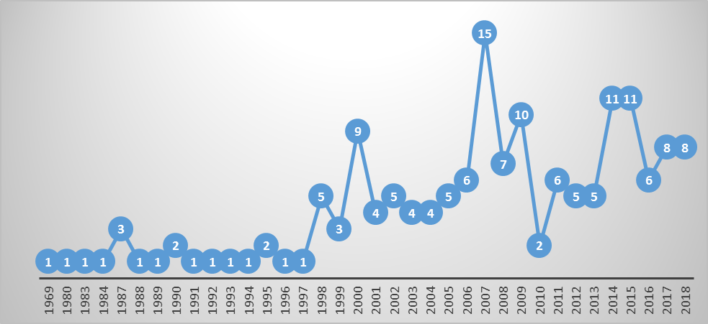
Figure 1. Text of the legend
- Numbered subtitle
This is the text of a normal paragraph. This is the text of a normal paragraph. This is the text of a normal paragraph. This is the text of a normal paragraph. This is the text of a normal paragraph. This is the text of a normal paragraph.
    - Numbered subtitle
This is the text of a normal paragraph. This is the text of a normal paragraph. This is the text of a normal paragraph. This is the text of a normal paragraph. This is the text of a normal paragraph. This is the text of a normal paragraph.
- References
Reminder: list only and all the works you cited.
Please follow the rules of APA 7th Edition and the instructions provided in the file “NAME_fichier_consignes”

Depecker, L. (2000). Le signe entre signifié et concept. In H. Béjoint & P. Thoiron (Eds.), Le sens en terminologie (pp. 86-126). Presses universitaires de Lyon.
Derico, B., & Kleinman, Z. (2023, November 7). OpenAI announces ChatGPT successor GPT-4. BBC News. https://www.bbc.com/news/technology-64959346
Bolaños-García-Escribano, A., Díaz Cintas, J., & Massidda, S. (2021). Latest advancements in audiovisual translation education. The Interpreter and Translator Trainer, 15(1), 1-12.
https://doi.org/10.1080/1750399X.2021.1880308
Hewson, L. (2011). An approach to translation criticism. Emma and Madame Bovary in translation. John Benjamins. https://doi.org/10.1075/btl.95
Peraldi, F. (1982a). Présentation. Meta, 27(1), 126-128.
Peraldi, F. (1982b). Psychanalyse et traduction. Meta, 27(1), 9-25.

Footnote text.
Footnote text.

