Instructions for the authors: insert your text into this file and use the styles provided.

Title of the article
- Numbered section title
This is the text of a normal paragraph. This is the text of a normal paragraph. This is the text of a normal paragraph. This is the text of a normal paragraph. This is the text of a normal paragraph. This is the text of a normal paragraph. This is the text of a normal paragraph. This is the text of a normal paragraph. This is the text of a normal paragraph.
This is an example of a quotation. This is an example of a quotation. This is an example of a quotation. This is an example of a quotation. This is an example of a quotation. This is an example of a quotation. This is an example of a quotation.
This is the text of a normal paragraph. This is the text of a normal paragraph. This is the text of a normal paragraph. This is the text of a normal paragraph. This is the text of a normal paragraph. This is the text of a normal paragraph.

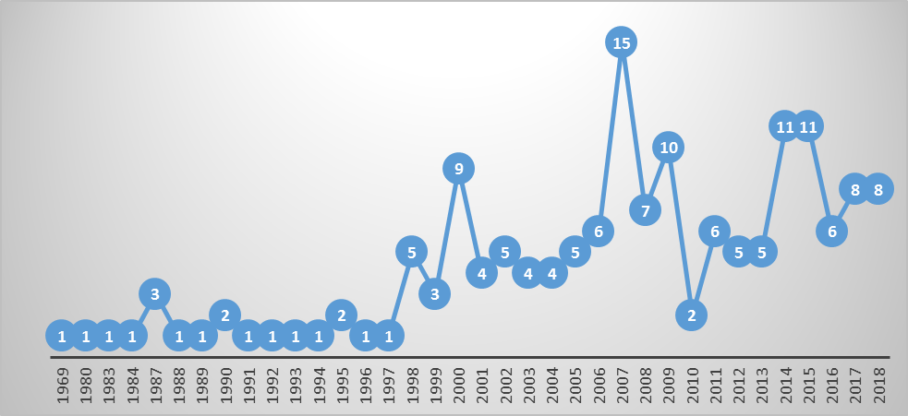
Figure 1. Text of the legend

Numbered subtitle
This is the text of a normal paragraph. This is the text of a normal paragraph. This is the text of a normal paragraph. This is the text of a normal paragraph. This is the text of a normal paragraph. This is the text of a normal paragraph.

Numbered subtitle
This is the text of a normal paragraph. This is the text of a normal paragraph. This is the text of a normal paragraph. This is the text of a normal paragraph. This is the text of a normal paragraph. This is the text of a normal paragraph.

References
Reminder: list only and all the works you cited.
Please follow the rules of the APA manual and the instructions provided in the file “NAME_fichier_consignes”

Depecker, L. (2000). Le signe entre signifié et concept. In H. Béjoint & P. Thoiron (dir.), Le sens en terminologie (pp. 86-126). Presses universitaires de Lyon.
Flórez, S. & Alcina, A. (2011). Catálogo de software libre para la traducción. Revista tradumàtica, 9, 57-73.
Hewson, L. (2011). An approach to translation criticism. Emma and Madame Bovary in translation. Amsterdam: Benjamins.
Peraldi, F. (1982a). Lecture psychanalytique et traduction du texte littéraire. Meta, 27(1), 126-128.
Peraldi, F. (1982b). Psychanalyse et traduction. Meta, 27(1), 9-25.
Traduction. (s.d.). In Wikipedia. Consulté le 11 juillet 2018, https://fr.wikipedia.org/wiki/Traduction.

Footnote text.
Example of a hypertext: http://www.unige.ch/. Please use font color black and don’t underline.

